# Media Analysis - ChatGPT outperforms copywriters in STEP Conference’s outdoor adverts

## Short Summary

ChatGPT, an OpenAI tool, is employed by Dubai's tech festival STEP Conference for enhancing efficiency in outdoor advertisements and boosting job satisfaction among team members, with plans to expand its use for content creation, summarization, and explanation tasks.

## Summary

1. **ChatGPT's Role in Ad Campaign**: ChatGPT, an AI tool developed by OpenAI, has been used to create and design outdoor adverts for the STEP Conference, an Arabic tech festival. The ads feature taglines like "Your money needs a side hustle," "Save the planet," and more.  
2. **Efficiency in Copywriting**: The company's founder, Ray Dargham, uses ChatGPT as an AI assistant to enhance efficiency among his team members in copywriting tasks, summarizing and explaining content when needed.  
3. **AI in Creative Industries**: The use of AI tools like ChatGPT in advertising reflects a growing trend where AI is increasingly involved in creative industries, potentially replacing some jobs traditionally done by humans but also augmenting productivity and efficiency.  
4. **Job Creation vs Job Displacement Debate**: While experts argue that AI has created more jobs than it has erased, with 85% of future jobs yet to be invented (as per one report), there is concern about job displacement in creative fields, similar to the portrayal seen in movies like "Her" and "Ex Machina."  
5. **ChatGPT's Complementary Role**: Dargham believes that ChatGPT functions more as a tool to enhance human capabilities rather than replacing them. He sees AI tools as complementing and sometimes even augmenting human talent, making tasks easier for copywriters who need constant creative output.  
6. **Future of Human Talent**: Dargham foresees a future where AI tools will both assist and potentially replace certain roles but emphasizes that human talent's value lies in its ability to find purposeful applications for advanced technology, utilizing it to bring more meaningful contributions.  
7. **Ethical Considerations**: As AI becomes more prevalent in job sectors traditionally managed by humans, there are ethical considerations regarding the fair treatment of those displaced by these technologies. It's crucial to strike a balance between leveraging AI for efficiency and ensuring human well-being and job security remain paramount.

## Question 1:

How do the media in this article frame the public discussion about ChatGPT? Are there certain **metaphors** that keep cropping up?

The media in this article frames the public discussion about ChatGPT through several strategic metaphors and analogies. It describes ChatGPT as an artificial intelligence AI assistant, an AI-driven tool that enhances efficiency and productivity for STEP Conference's team in creating content introduces AI into an industry traditionally dominated by humans to illustrate the emerging era of AI-driven industries and uses a dichotomy to discuss ChatGPT's role - it will both complement and potentially replace human creativity. These metaphors collectively contribute to a nuanced public discussion about ChatGPT, highlighting both its transformative potential and the evolving nature of work in the era of advanced technology.

## Question 2:

Which role does or might the Arabic World play in the development of Artificial Intelligence? Answer with 'Not mentioned' if not applicable.

Not mentioned

## Question 3:

Which use cases of Artificial Intelligence are helpful for the Arabic world based on this article?

ChatGPT is used by STEP Conference for creating outdoor advertisements, while other AI tools are employed for writing session briefs, social posts, and general content generation. These applications of AI demonstrate its potential in advertising, marketing, and content creation sectors within the Arabic world.

## Question 4:

What is the final message of the article that the author wants to convey? Keep your answer short and precise!

The final message is that AI tools like ChatGPT can enhance productivity and complement human creativity in the workplace, suggesting a collaborative relationship between machines and human talent.

## Sentiment

The sentiment is <3>

The sentiment of the article is mixed, leaning towards positive with some concerns highlighted. The company's use of ChatGPT for various tasks and its potential benefits are acknowledged. However, there are also apprehensions about job displacement due to AI tools like ChatGPT. Thus, the overall sentiment can be considered slightly positive but not overwhelmingly so.

## Entities

Zaira Lakhpatwala, Dargham

## Topic Clusters

### Cluster: AI and Technology Focus

Artificial Intelligence, ChatGPT

### Cluster: Conference Insights

STEP Conference

### Cluster: Advertising Innovations

Advert Creation

### Cluster: Creative Applications of AI

AI-generated Taglines

## Word Clouds

### Wordcloud of content

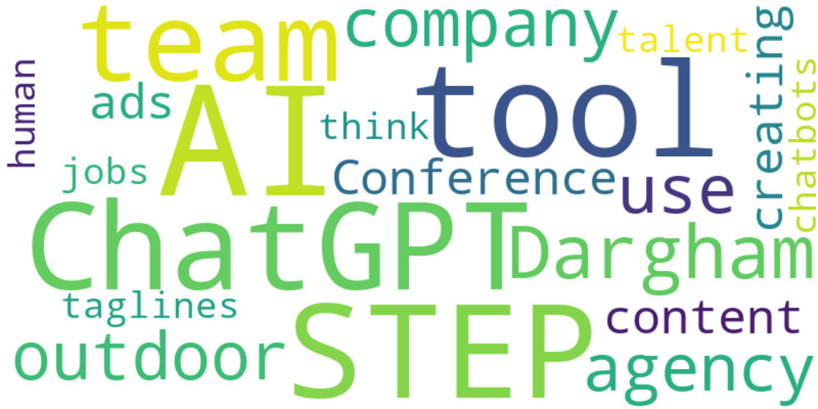

Top 10 words:

- AI: 10  
- STEP: 7  
- ChatGPT: 6  
- like: 6  
- team: 5  
- Dargham: 5  
- outdoor: 4  
- company: 4  
- use: 4  
- agency: 4

### Wordcloud of summary

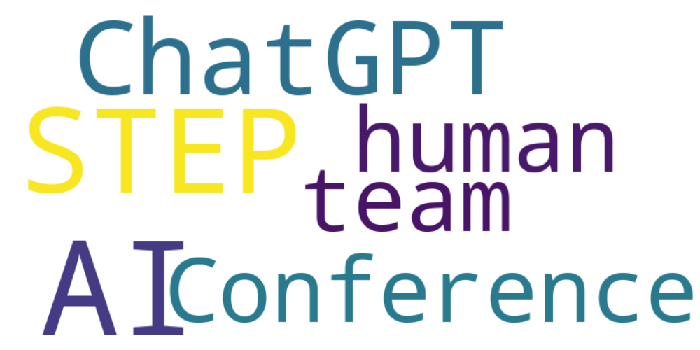

Top 10 words:

- AI: 10  
- ChatGPT: 6  
- human: 4  
- like: 3  
- Dargham: 3  
- efficiency: 3  
- tools: 3  
- creative: 3  
- jobs: 3  
- job: 3